NCP Academy Training on
“RRI and Ethics in Horizon 2020”
Date: 4th and 5th April 2017
Location: Grenanderhaus, DLR Project Management Agency;
Rosa-Luxemburg-Str. 2
10178 Berlin

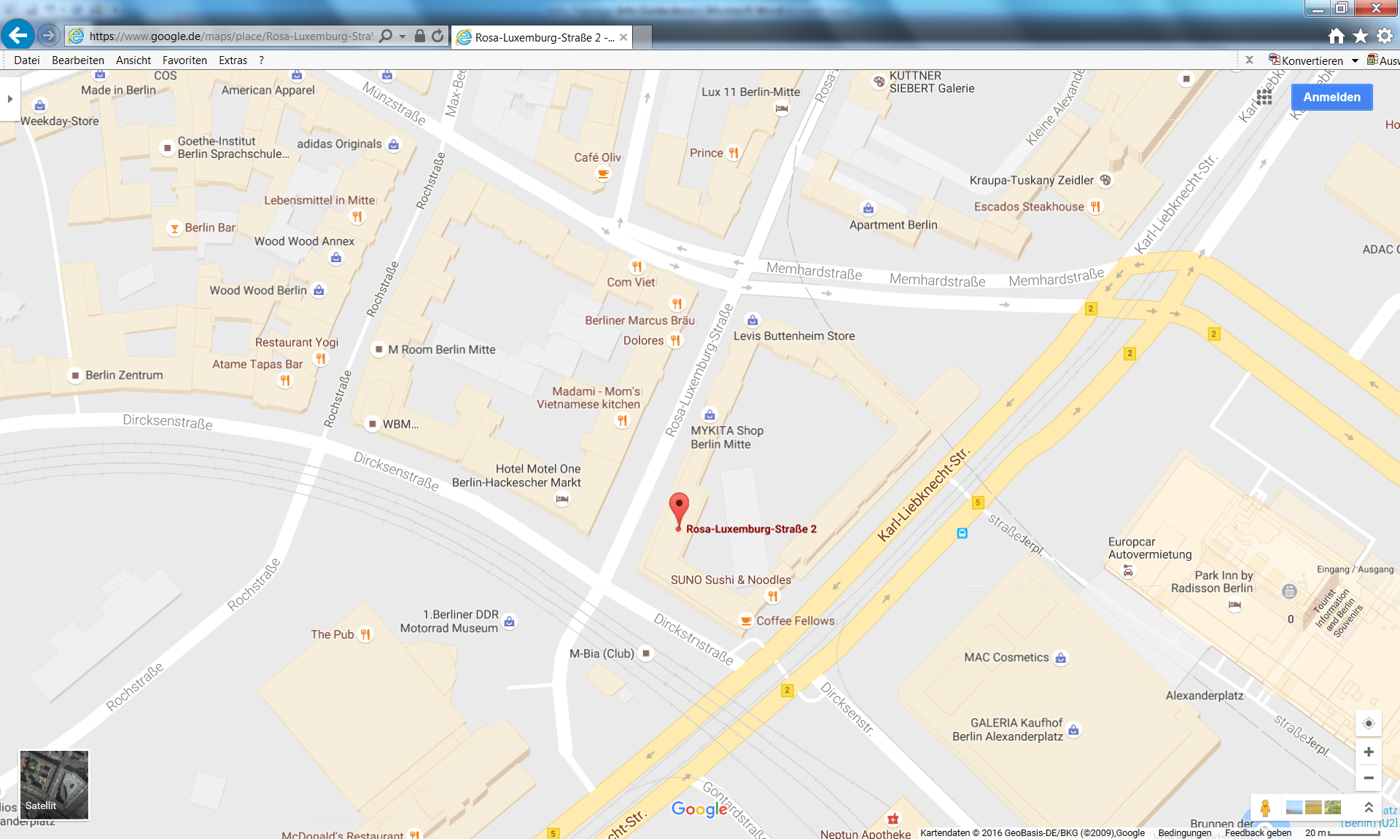

Public transport:
Take S+U-Bahn to Alexanderplatz or U-Bahn to Rosa-Luxemburg-Platz. Rosa-Luxemburg-Str. 2 is just a few minutes away on foot.

Long-distance trains:
From Berlin Hauptbahnhof or Berlin Ostbahnhof take a regional train or S-Bahn to Alexanderplatz. Rosa-Luxemburg-Str. 2 is just a few minutes away on foot.

From Tegel-Airport:
Take bus TXL towards Alexanderplatz. Alight at stop S+U Alexanderplatz Bhf/Memhardstraße (journey time approx. 40 minutes). The rear of the “Grenanderhaus” building is opposite the stop; the entrance is approx. 150 metres away.

From Schönefeld Airport:
Take the regional train to Alexanderplatz. Rosa-Luxemburg-Str. 2 is just a few minutes away on foot.

Hotel recommendations

Hotel Motel One Berlin-Hackescher Markt | berlin-hackeschermarkt@motel-one.com
Park Inn by Radisson Hotel | http://www.parkinn-berlin.de/en/contactus/
Ramada Hotel Berlin Alexanderplatz | https://www.h-hotels.com/en/ramada/hotels/ramada-hotel-berlin-alexanderplatz
Holiday Inn Alexanderplatz | http://hiberlincenter.com/

