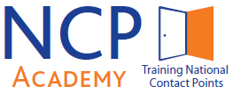

Training in Cross-Cutting Issues
22nd and 23rd of February 2018, Lisbon

Agenda
22nd of February |  | 23rd of February
8:30 Welcome address and introduction to the NCP Academy - GPPQ/FCT  Gender Issues Ethics in H2020  Gender equality provisions in Horizon 2020  Sector “Gender” DG RTD (tbc)  Gender dimension in research content - what it means and how to integrate in research projects  Katrien Vanderheyden, Yellow Window |  | 9:00 Ethics in H2020  Ethics issues - Horizon 2020  Ethics issues - Evaluator guidelines  Filipa Ferraz de Oliveira, ERCEA
13:00 Lunch break |  | 13:00 Lunch break
14:00 Open Science  Open Science  Eloy Rodrigues, University of Minho  17:00 End of session |  | 15:00 End of session
19:30 Networking dinner

